Year | Prepared By:
2018 | Mark Falkner- Director of Security

Crime/Incident Statistics
Serious Felony Crimes
Security Company | Trident Security |  | Before Trident
Issue/Incident | 2018 | 2017 | 2016 | 2015
Any Other Felony | 0 | 0 | 0 | 1
Arson | 0 | 0 | 0 | 0
Burglary | 1 | 3 | 5 | 5
Forgery/Counterfeit | 0 | 2 | 1 | 0
Fraud | 1 | 3 | 11 | 15
Homicide | 0 | 0 | 0 | 0
Kidnap/Abduction | 0 | 0 | 0 | 0
Robbery | 0 | 6 | 2 | 3
Sexual Assault/Battery | 1 | 1 | 0 | 2
Totals | 3 | 15 | 19 | 26
 | 18 |  | 45
Comments:

- 2018 had only 3 Serious Felony Crimes.
- 2018 had 12 less Serious Crimes than in 2017, which had 15.
- This is a reduction of 80% in Serious Felony crimes from 2017.
- 2018 had 16 less Serious Crimes than in 2016 and 23 less incidents than in 2015.
- 2017 had a 21% decrease from 2016. 2016 had a 26% decrease from 2015.

Incident Summary:

- Burglary: 1-8-2018, This occurred at Dave & Busters during construction. Someone entered the construction space and stole parking passes and did graffiti on the walls.

- Alleged Sexual Assault: 4-20-2018, Security was notified by police that an 18-year-old female was sexually assaulted in the A1 restrooms, near Costa Vida, by an acquaintance and fellow student from West High. The female and male were both seen leaving the restroom on camera. Police stated that the female is not cooperating with the investigation and that the male was identified.

- Fraud: 12-3-2018, Panda Express an individual used a stolen credit card to purchase food at Panda Express.

Serious Felony Crimes: Month to Month stats
Month | JAN | FEB | MAR | APR | MAY | JUN | JUL | AUG | SEP | OCT | NOV | DEC
2017 | 2 | 1 | 3 | 0 | 2 | 2 | 0 | 1 | 0 | 1 | 1 | 2
2018 | 1 | 0 | 0 | 1 | 0 | 0 | 0 | 0 | 0 | 0 | 0 | 1
Comments:

- There were 0.25 Serious Felony Crimes per month in 2018.
- There were 1.25 Serious Felony Crimes per month in 2017.
- There were no Serious Felony Crimes reported from May to November.
- In 2017 there were 2 months that had no reported incidents.
- In 2018 there were 9 months that had no reported incidents.

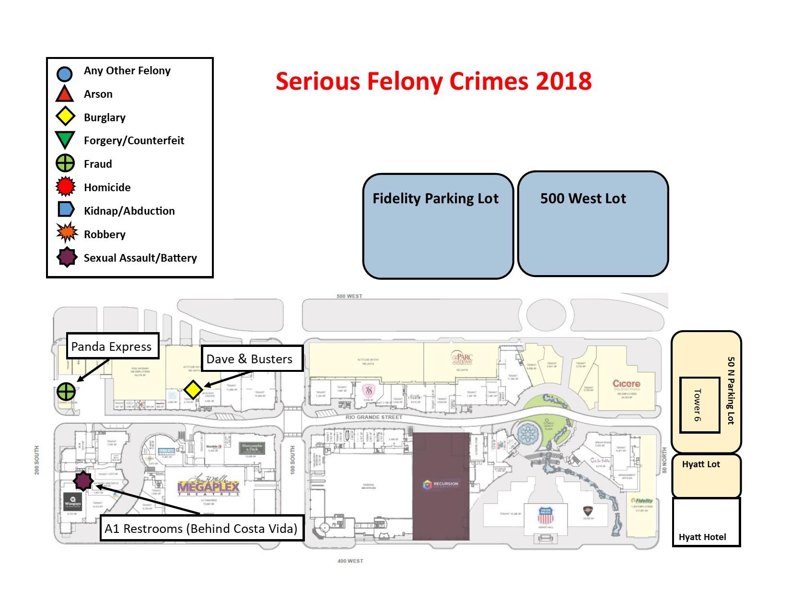

Drug Related Crimes
Security Company | Trident Security |  | Before Trident
Issue/Incident | 2018 | 2017 | 2016 | 2015
Controlled Substance Possession | 5 | 18 | 52 | 70
Drug Acts: Hand to Hand trans | 0 | 1 | 4 | 14
Drug Acts: Vehicle | 1 | 6 | 15 | 47
Drug Paraphernalia | 21 | 48 | 169 | 246
Totals | 27 | 73 | 240 | 377
 | 100 |  | 617
Comments:

- There were 27 reported drug crimes in 2018, this is 46 less than in 2017.
- This was a decrease of 63% from 2017.
- There has been an overall decrease of 92% from 2015 numbers.

Drug Related Crimes Month to Month Stats
Month | JAN | FEB | MAR | APR | MAY | JUN | JUL | AUG | SEP | OCT | NOV | DEC
2017 | 12 | 7 | 8 | 7 | 4 | 7 | 8 | 7 | 0 | 4 | 4 | 2
2018 | 6 | 1 | 3 | 4 | 0 | 4 | 4 | 2 | 1 | 0 | 0 | 2
Comments:

- In 2017 we had an average of 6 Drug incidents per month.
- In 2018 we had an average of 2.25 incidents per month.
- Highest months were Jan, April, June, and July.
- May, October and November had Zero reported incidents.
- 2017 only had one month with no reported incidents.

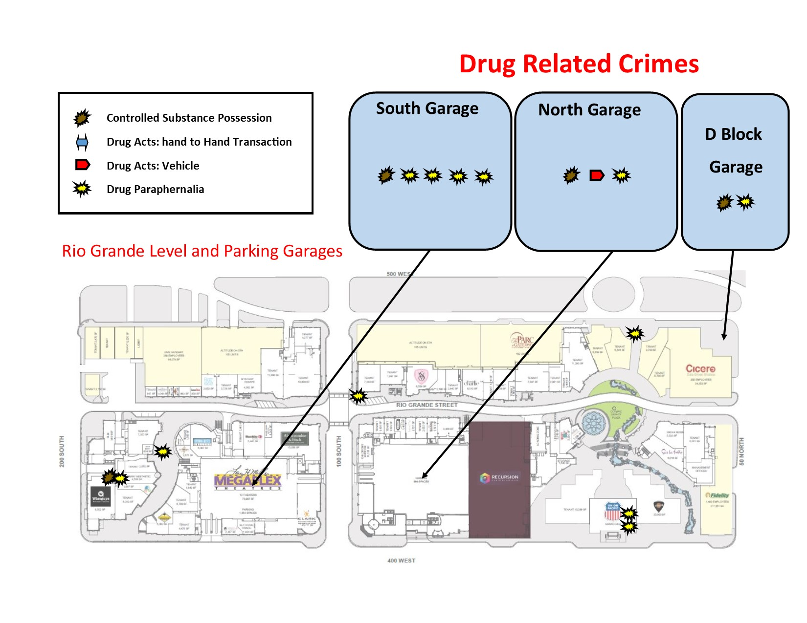

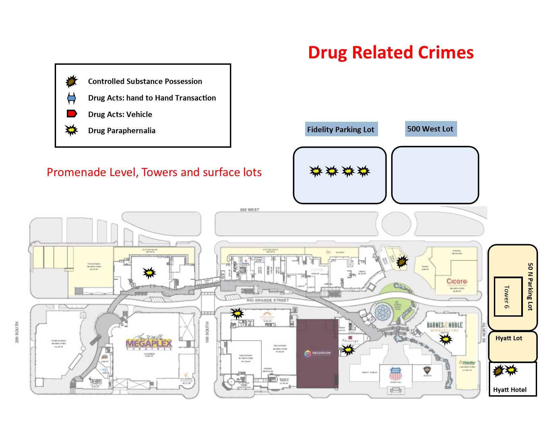

Property Crimes
Security Company | Trident Security |  | Before Trident
Issue/Incident | 2018 | 2017 | 2016 | 2015
Criminal Damage to Property | 49 | 4 | 8 | 10
Criminal Damage to Property: Felony | 1 | 0 | 0 | 0
Graffiti/Etching | 18 | 50 | 118 | 113
Theft: Felony | 3 | 6 | 1 | 3
Theft: Misdemeanor | 11 | 15 | 22 | 51
Theft: From Building | 13 | 4 | 2 | 7
Theft: Other | 8 | 8 | 33 | 63
Theft: Purse Snatch | 0 | 0 | 0 | 6
Theft: Services | 1 | 12 | 10 | 17
Theft: Shoplifting- Felony | 7 | 6 | 8 | 9
Theft: Shoplifting- Misdemeanor | 23 | 73 | 180 | 308
Totals | 134 | 178 | 382 | 587
 | 312 |  | 969
Comments:

- There were 113 reported Property Crimes in 2018.
- This was 44 less incidents than in 2017.
- There were 204 less Property Crimes in 2017 than in 2016.
- There were 453 less Property Crimes in 2018 than in 2015.
- There was a 25% decrease in 2018 from 2017.
- There was a decrease of 77% from 2015 numbers.
- Most crime categories have decreased significantly over the years except for Theft from Building (due to the amount of construction) and Criminal Damage to Property (which most of those are damage to gumball machines).
- The most significant reduction is with Shoplifting, which may be in part due to the transition from Retail stores to office/entertainment type stores.
- The frequency of Graffiti is also significantly reduced over the years.

Property Crimes Month to Month Stats
Month | JAN | FEB | MAR | APR | MAY | JUN | JUL | AUG | SEP | OCT | NOV | DEC
2017 | 38 | 31 | 18 | 19 | 18 | 19 | 26 | 11 | 11 | 11 | 20 | 13
2018 | 12 | 9 | 6 | 10 | 4 | 4 | 16 | 11 | 3 | 8 | 23 | 7
Comments:
- 2017 had an average of 14.8 incidents per month.
- 2018 had an average of 9.4 incidents per month.
- Highest months were Jan, April, July, August and September.

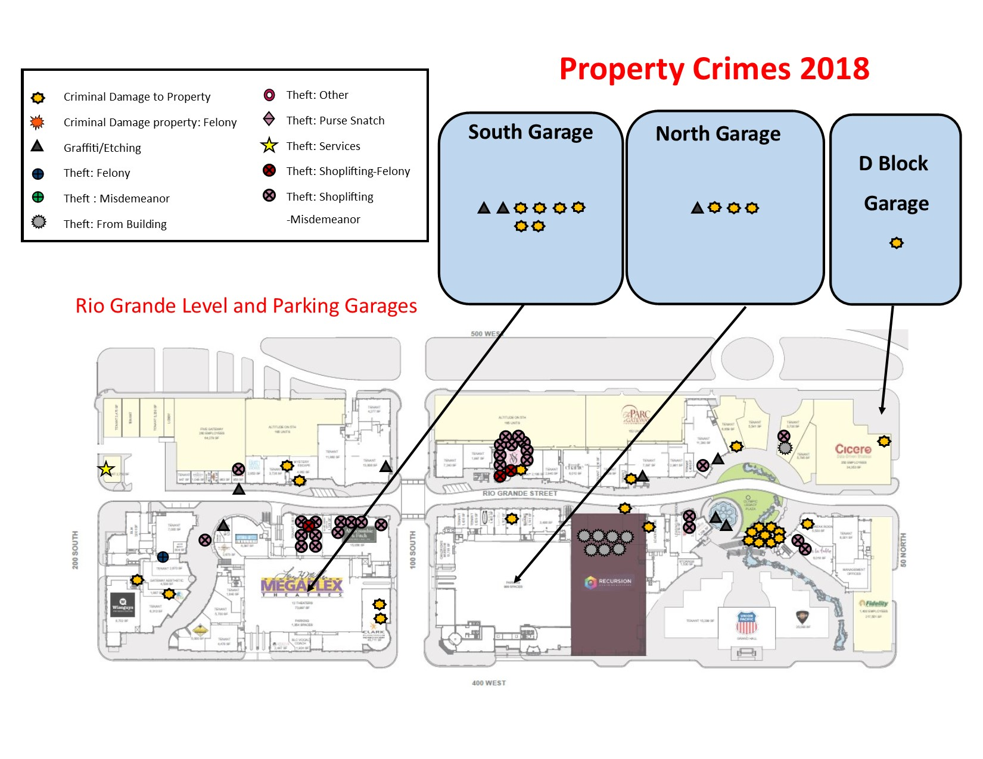

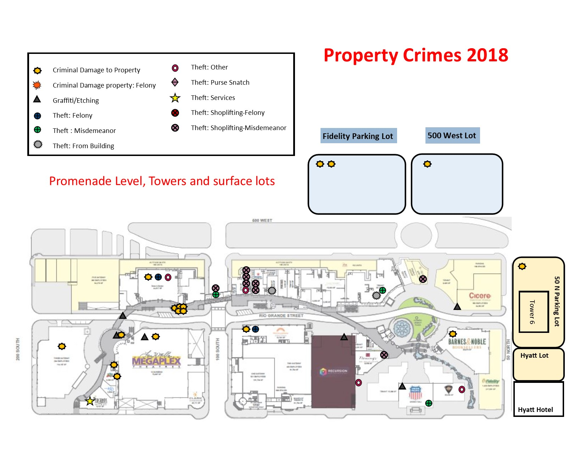

Behavior Crimes/incidents
Security Company | Trident Security |  | Before Trident
Issue/Incident | 2018 | 2017 | 2016 | 2015
Alcohol Violation | 1 | 0 | 2 | 15
Assault: Simple or Aggravated | 0 | 17 | 25 | 38
Disorderly Conduct | 13 | 28 | 54 | 47
Disturbance | 30 | 54 | 155 | 219
Dress Code Violation | 2 | 38 | 0 | 0
Harassment | 2 | 2 | 4 | 4
Health or Safety Risk: Offense | 10 | 10 | 48 | 43
Lewdness: Indecent Exposure | 1 | 6 | 6 | 7
Lewdness: Obscene Acts | 8 | 4 | 9 | 14
Lewdness: Public Urination | 3 | 5 | 5 | 5
Loitering | 13 | 28 | 111 | 134
Mall Rule Violation | 66 | 76 | 149 | 78
Panhandling | 21 | 62 | 120 | 155
Public Intoxication | 20 | 32 | 79 | 52
Sleeping In Common Areas | 26 | 19 | 98 | 216
Soliciting | 2 | 0 | 8 | 22
Suspicious Activity | 32 | 176 | 435 | 490
Trespass | 89* | 432 | 644 | 560
Unwanted Person | 128* | 23 | 10 | 58
Weapons Offense | 0 | 0 | 0 | 1
Totals | 463 | 1012 | 1962 | 2158
 | 1475 |  | 4120
Comments:
- We had 463 reported Behavior Incidents in 2018.
- We had 549 less incidents in 2018 than we did in 2017.
- We had 950 less Behavior incidents in 2017 than in 2016.
- There were 196 more Behavior Crimes in 2015 than in 2016.
- There was a decrease of 54% from 2017 to 2018.
- There was a 9% drop from 2015 to 2016 and a 48% drop from 2016 to 2017.
- There is an overall decrease of 79% from 2015 numbers.
- *We made a change in our reporting to make the stats more accurate. Before the change, if someone was kicked out for a violation they would list the initial incident as a “trespass” because they were trespassed. I changed this to report what the violation was initially and then trespassing if they returned because it is not trespassing unless they refuse to leave or return after being kicked out. This is the reason the stats numbers are so different than previous numbers, as “Trespass” and “Unwanted Person” seem to have flip flopped.

Behavior Crimes Month to Month Stats
Month | JAN | FEB | MAR | APR | MAY | JUN | JUL | AUG | SEP | OCT | NOV | DEC
2017 | 79 | 164 | 114 | 113 | 97 | 90 | 124 | 53 | 23 | 47 | 47 | 44
2018 | 66 | 66 | 43 | 34 | 17 | 30 | 42 | 44 | 27 | 28 | 29 | 37
Comments:

- In 2017 we had an average of 84.3 Incidents per month.
- In 2018 we had an average of 38 incidents per month.
- The highest months were January and February, which may be related to cold weather/transient activity.

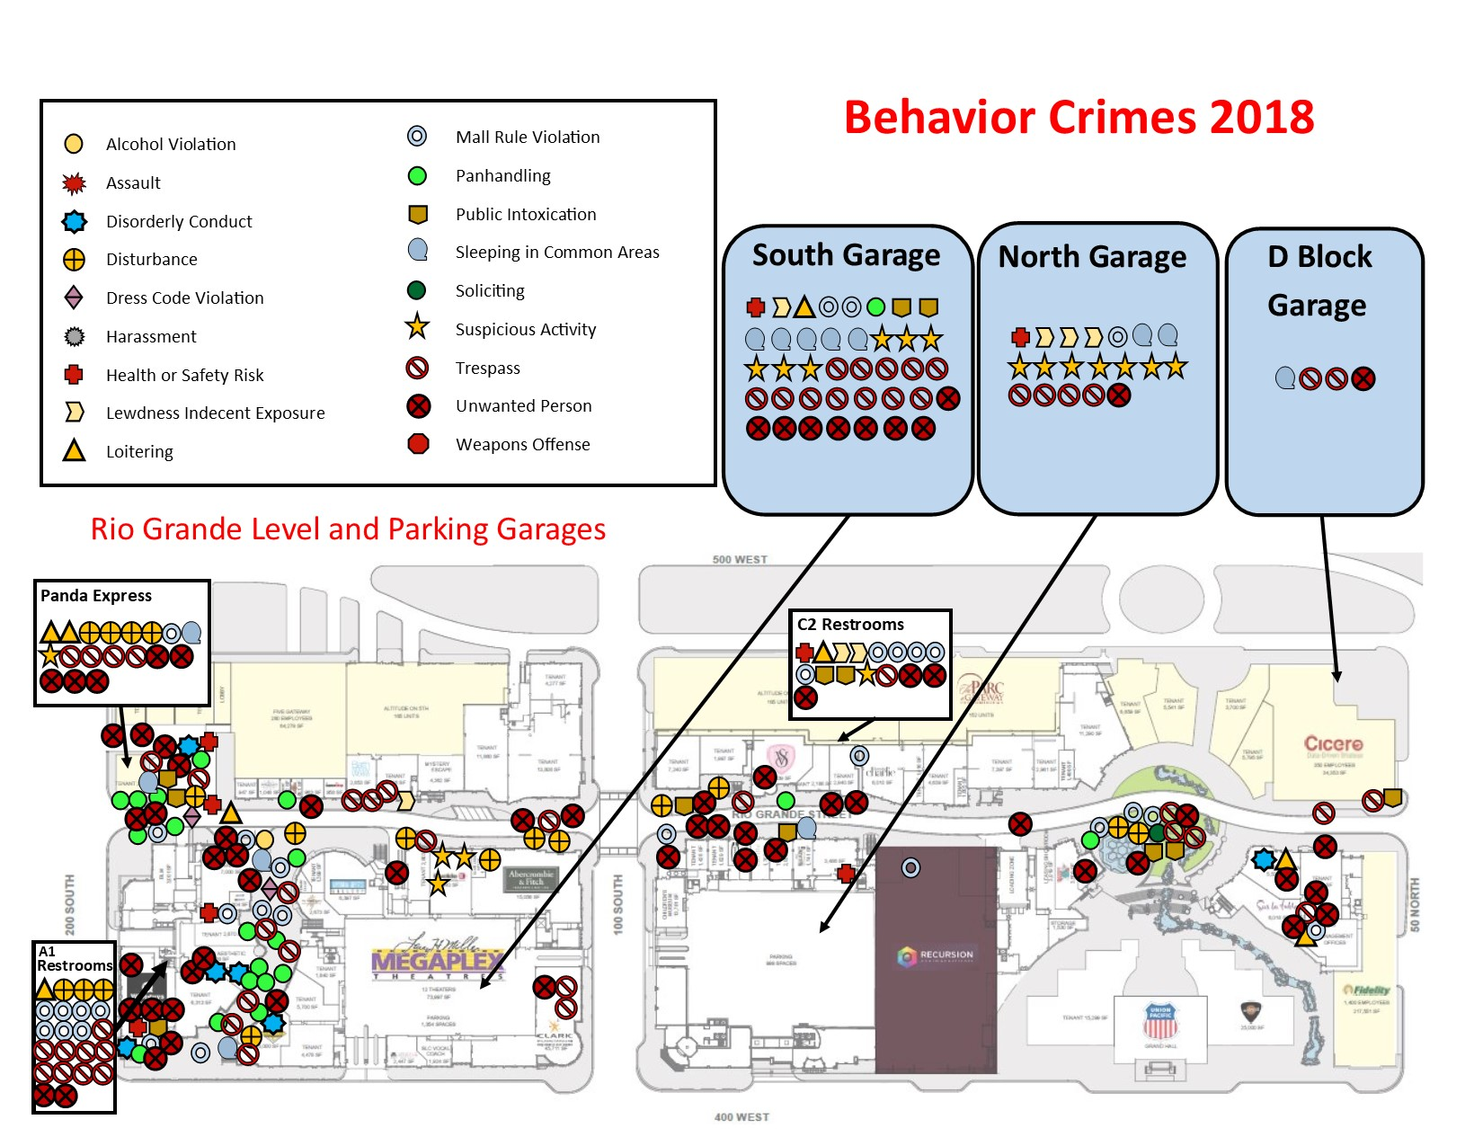

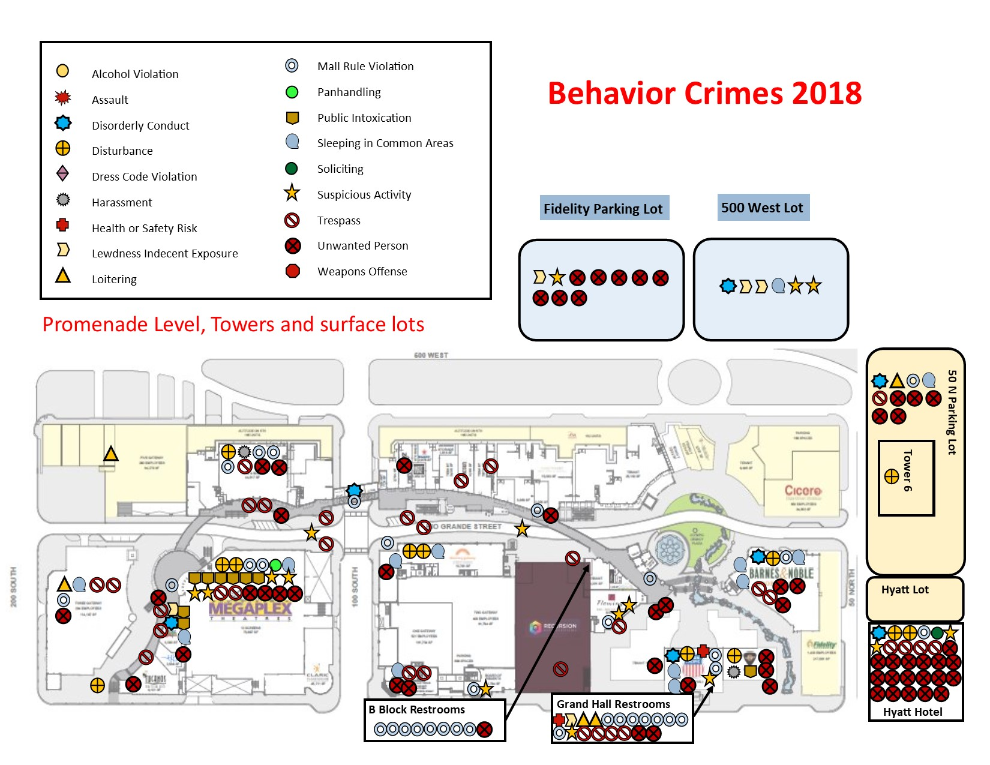

Vehicle Crimes
Security Company | Trident Security |  | Before Trident
Issue/Incident | 2018 | 2017 | 2016 | 2015
Criminal Damage to Property: Vehicle | 15 | 6 | 9 | 12
Recovered Stolen Auto | 1 | 1 | 3 | 1
Theft: Automobile | 1 | 9 | 7 | 8
Theft: From Vehicle | 44 | 64 | 79 | 40
Theft: Vehicle Parts/Accessories | 0 | 1 | 3 | 3
Totals | 61 | 81 | 101 | 64
 | 142 |  | 165
Comments:

- We had 61 reported Vehicle crimes in 2018.
- We had 20 less vehicle crimes than in 2017.
- This is a reduction of 25% from 2017 to 2018.
- We had 20 less Vehicle crimes in 2017 than in 2016.
- However, 2016 had 37 more Vehicle crimes than in 2015.
- This is the first category area where 2015 had less incidents than in 2016 or 2017. But 2018 numbers were lower than 2015 numbers
- There was an 18% drop from 2016 to 2017, but a 57 % increase from 2015 to 2016.

Vehicle Crimes Month to Month Stats
Month | JAN | FEB | MAR | APR | MAY | JUN | JUL | AUG | SEP | OCT | NOV | DEC
2017 | 7 | 7 | 11 | 6 | 6 | 8 | 10 | 3 | 2 | 4 | 8 | 9
2018 | 5 | 1 | 10 | 8 | 3 | 6 | 5 | 4 | 2 | 8 | 9 | 0
Comments:

- There was an average of 6.75 Incidents per month in 2017.
- There was an average of 5.08 Incidents per month in 2018.
- The highest months this year were March, April, October, and November.
- However, for the first time I am aware of in Gateway history we had zero vehicle crimes in a month and this was for the month of December.

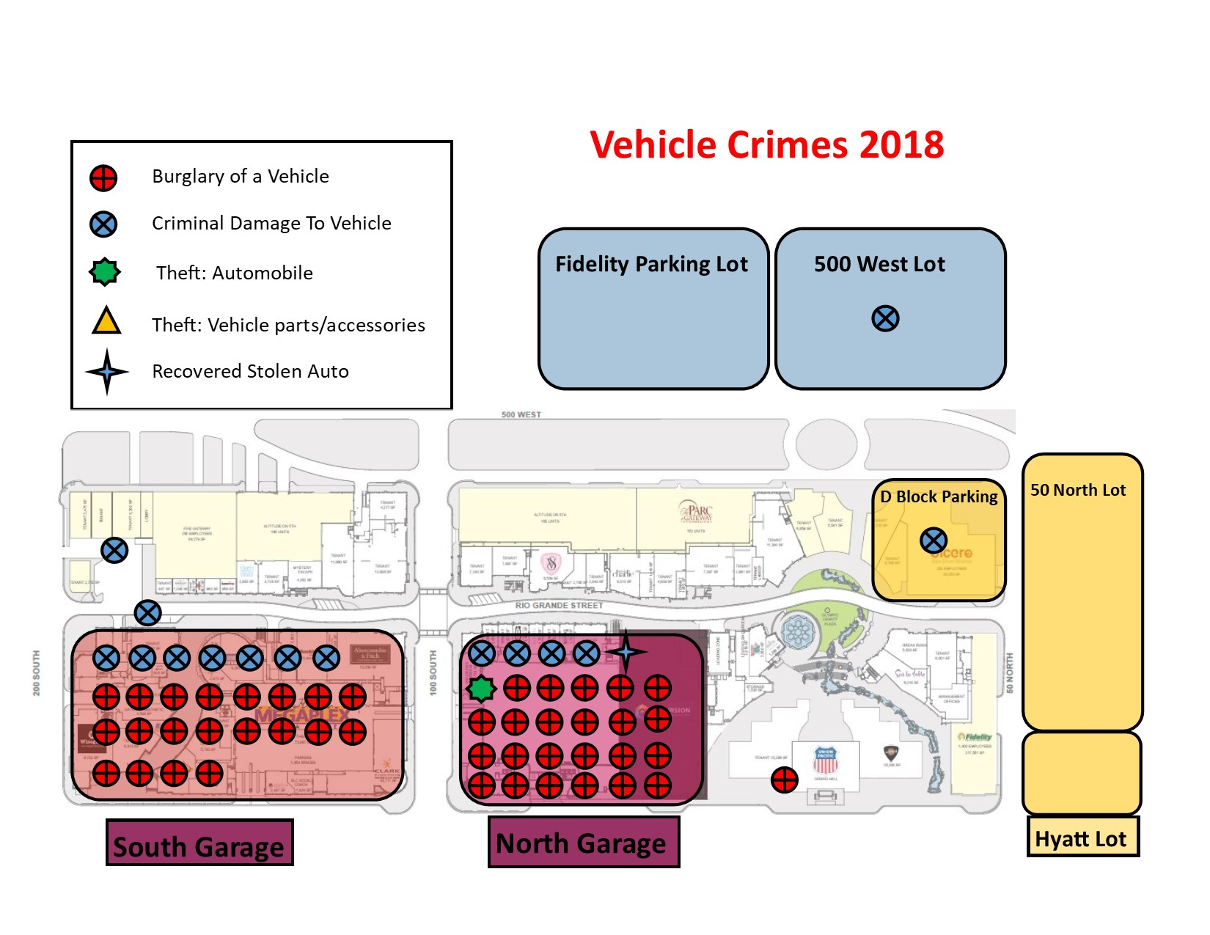

Miscellaneous incidents
Security Company | Trident Security |  | Before Trident
Issue/Incident | 2018 | 2017 | 2016 | 2015
Bomb Threat | 1 | 0 | 1 | 0
Elevator Entrapment | 4 | 1 | 7 | 1
Fire | 1 | 8 | 5 | 12
Flooding | 1 | 0 | 3 | 0
Hazardous Material/Fluid Spill | 2 | 0 | 7 | 2
Health or Safety Risk Incident | 34 | 13 | 26 | 78
Medical/Sick Call | 48 | 54 | 86 | 126
Slip/Fall | 23 | 21 | 37 | 23
Suicide/Suicide Threat | 0 | 1 | 1 | 1
Suspicious Package | 0 | 0 | 3 | 1
Vehicle Accident | 25 | 20 | 37 | 22
Vehicle Accident: Auto-Ped or Bike | 1 | 3 | 24 | 1
Vehicle Accident: Hit and Run | 12 | 8 | 0 | 17
Water leak | 121 | 139 | 165 | 216
Totals | 273 | 268 | 378 | 500
 | 541 |  | 878
Comments:
- Miscellaneous incidents are incidents that are important to include but are not directly related or affected be security patrols or are items that are out of our control but are important to list.
- There were 273 Miscellaneous incidents in 2018. This was slightly up from 2017 umbers.
- There has been a significant drop from 2016 and 2015 numbers.
- There were more health or safety risk incidents (safety concerns) noticed this year vs last year.
- However, there were a few fewer medical calls in 2018 than in 2017.
- There were less water leak reports in 2018 from 2017.
- There were a few more traffic accidents in 2018 than in 2017 but less pedestrian/bicycle accidents. However, there were more hit & run accidents.

Miscellaneous Incidents Month to Month Stats
Month | JAN | FEB | MAR | APR | MAY | JUN | JUL | AUG | SEP | OCT | NOV | DEC
2017 | 42 | 31 | 22 | 31 | 23 | 16 | 27 | 12 | 14 | 16 | 17 | 17
2018 | 27 | 33 | 23 | 26 | 25 | 19 | 26 | 22 | 15 | 38 | 8 | 13
Comments:

- There was an average of 22.75 incidents a month in 2018.
- There was an average of 22.33 incidents a month in 2017.

Stats by Quadrant
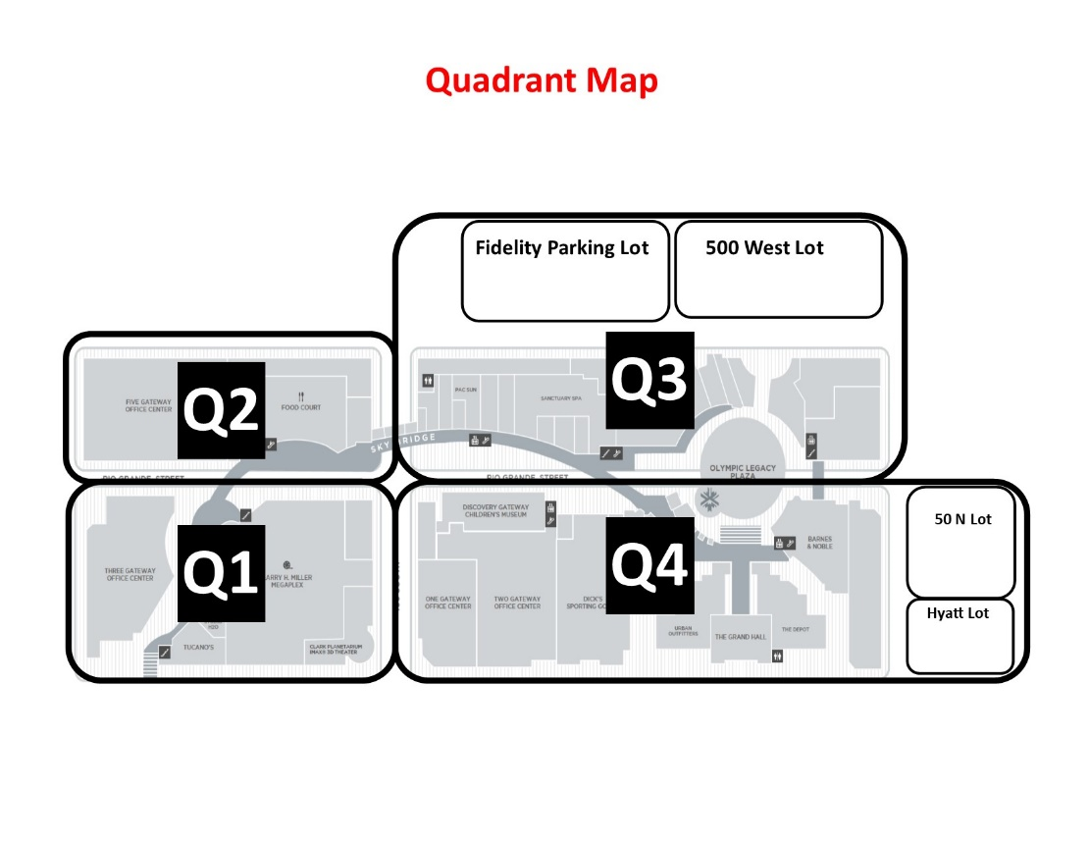
Stats by Quadrant
Serious Felony Crimes
Q1 | Q2 | Q3 | Q4
1 | 2 | 0 | 0
Drug Related Crimes
Q1 | Q2 | Q3 | Q4
8 | 1 | 11 | 7
Property Crimes
Q1 | Q2 | Q3 | Q4
35 | 17 | 35 | 40
Behavior Crimes/Incidents
Q1 | Q2 | Q3 | Q4
179 | 61 | 45 | 178
Vehicle Crimes
Q1 | Q2 | Q3 | Q4
28 | 1 | 2 | 30
Totals
251 | 82 | 93 | 255

Comments:

- 32 % of all incidents occur in common area spaces.
- 31 % of all incidents occur inside of tenant spaces, this includes stores, restaurants, Megaplex, Discovery Gateway, and office tenants.
- 27 % of all incidents occur in Parking garages and surface lots.
- 10 % of all incidents occur in restrooms.

Comments:

- The majority of restroom incidents occur in either the A1 or Grand Hall Restrooms.
- 25 % of all restroom incidents occur in the A1 Restrooms near Costa Vida.
- 21% of all restroom incidents occur in the Grand Hall Restrooms.
- 16% of all restroom incidents occur in the C2 Restrooms.
- 14 % of all restroom incidents occur in the B Block Restrooms.
- It should be noted that the B block restrooms were only open for 1 month of the year. If the restrooms had been open all year and we use the same numbers that December had, we would have had 120 incidents. This would have attributed to 66% of all restroom incidents and would be almost 5 times more than the A1 restrooms.

Comments:

- The vast majority of parking lot incidents occur in either the South or North Garage with South Garage having more than North Garage. However, they are both much larger than the other lots.
- 67 % of all parking lot incidents occur in the South Garage.
- 55% of all parking lot issues occur in North Garage.
- 27% of all parking lot issues occur in the Tower 5 Lot which is a very small lot, but is closest to the homeless shelter.
- 8% of all parking lot incidents occur in Fidelity Lot.
- 5 % of all parking lot incidents occur in the 50 North Lot.
- 4 % of all parking incidents occur in each of the D Block Garage and 500 West Lot.
- There were no reported incidents in the Hyatt Lot.

General Comments/overview

- There were 688 total incidents in 2018. There were 1359 total incidents in 2017. In 2015 there were 3203 total incidents.
- We saw a total reduction in criminal incidents of 49% from 2017 and 79% decrease from 2015 numbers.
- Serious Felony Crimes are significantly reduced from last year and have been dropping every year since 2015. The biggest drop was from 2017 to 2018 showing an 80 % reduction.
- All the serious Felony Crimes occurred on the south end of the property.
- Drug Crimes have also continued to decrease with significant decreases every year since 2015. We have had a 92 % decrease from 2015 numbers and a 63 % decrease from 2017.
- Drug crimes are evenly distributed around the property.
- Property Crimes have steadily decreased since 2015. There was a 77 % decrease from 2015 numbers and 25% decrease from last year.
- Property Crimes are mostly spread out across the property. The #1 issue was gumball machines getting broken into. Second was shoplifts at Victoria’s secret, followed by shoplifts at The Buckle, Zumiez, and Abercrombie.
- Behavior Crimes have significantly decreased since 2015 showing a 79% decrease from 2015 and a 54% decrease from last year.
- Behavior Crimes comprise most incidents that we have at The Gateway. Most of the Behavior Crimes are on the south end and Restaurant Row area, with the restrooms, garages, Panda Express, Megaplex, and the Hyatt Hotel as other hot spot areas.
- Vehicle Crimes have slightly decreased from 2015 numbers. However, 2016 had the highest number in the past 4 years. We had a 25 % reduction from last year.
- Almost all the Vehicle Crimes are in the South and North Garages.
- Breaking down the property into Quadrants as illustrated by the map on the previous pages we see that Quadrant 1 and 4 have significantly more incidents than the other quadrants and are relatively close in numbers. Quadrant 2 and 3 also have similar numbers to each other. Last year Quadrant 1 had most of the issues.
- About 1/3 of the incidents occur inside of tenant spaces, 1/3 of incidents occur in Common areas, and the final 1/3 occur in garages, lots and restrooms.
- Most restroom incidents occur in the A1 Restrooms or Grand Hall Restrooms. However, B block Restrooms were only open for 1 month and if the same numbers were applied throughout the year would have had 66% of the total incidents.
- In parking areas South and North Garages had the most incidents but they are by far the larger areas. The Tower 5 Lot, which is the smallest lot, had a disproportionately higher incident rate per size than the rest. Which is likely due to the proximity to the homeless shelter.
- Trident Security continues to be vigilant and will use these stats to adjust deployments and posts to better serve the property and crime issues. We believe we have made a significant impact in all areas since taking over the contract at The Gateway. We strive for excellence and will do whatever it takes and then some.

