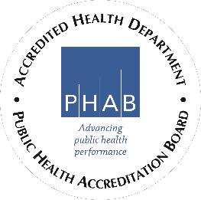
151 N Main St, Tooele, UT 84074
(O) 435-277-2300
(F) 435-277-2464
www.tooelehealth.org

FOR IMMEDIATE RELEASE
May 21, 2020

MEDIA CONTACT:
Jacqueline Castro
435-277-2320/801-657-9861
jcastro@tooelehealth.org

Utah Business Revival Unpermitted Mass Gathering

Today we became aware that the Utah Business Revival announced they would be moving their Collin Raye concert to the Studio Ranch Amphitheater located in Tooele County. This event has not been approved by Tooele County or the Tooele County Health Department.

According to state code R392-400 all mass gatherings over 1000 people must receive a permit by the health department where the event will be located. No permit application has been received by Tooele County Health Department to review. This review covers mass gathering event strategies for restrooms, traffic, safety, and other concerns.

COVID-19 transmission adds an additional worry because at an event like this it is nearly impossible to maintain social distancing. Tooele County Health Department is very concerned about the lack of permitting for this event. Our greatest concern is for the health and safety of our citizens. After an event is held without a permit it is possible for the health department to file charges against the property owner for allowing an unpermitted event to take place.

Public health cannot anticipate every unique situation. Residents must take personal responsibility to take actions based on common sense and wise judgment that will protect health and safety. Utah and Tooele County are doing a great job flattening the COVID-19 curve and we do not want to see a spike in COVID-19 cases come from an unapproved event like this. We want to promote community unity and at the same time protect the health and wellbeing of our citizens.

